1. Difference between build, rebuild, clean
2. Build: if code changes, compile files
3. Rebuild: clean + build(regardless of whether changed)
4. Clean: delete all compiled files
5. Rebuild vs clean + rebuild:

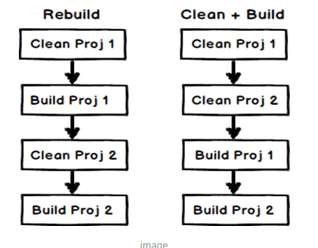

1. Build vs rebuild

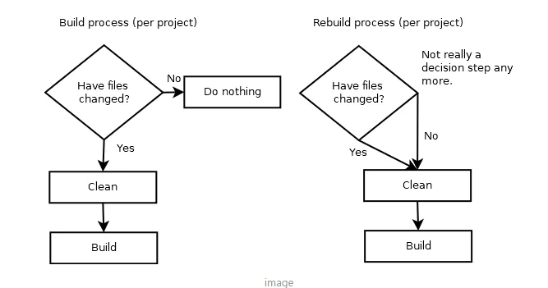

1. Build vs deploy:

Build: generate dll’s

deploy: generate dll’s and necessary files, then push them to a specified location(such as IIS Server)

1. What is assembly?

Assembly is partial compile code used for deployment.

Two types: Process assemblies(EXE)

Library assemblies(DLL)